Why?
Photosynthesis: What’s in a Leaf?
What is the relationship between structure and function in a leaf?

What would the world be like without leaves—no grass for ball fields, no beautiful landscaping? It would also mean no oxygen for animals and no food for heterotrophs. Leaves are like living machines that recycle the carbon and oxygen in our environment. This process, driven by the sun’s energy, allows for a constant supply of oxygen and food for the inhabitants of Earth.

Model 1 – Leaf Sun-Catcher
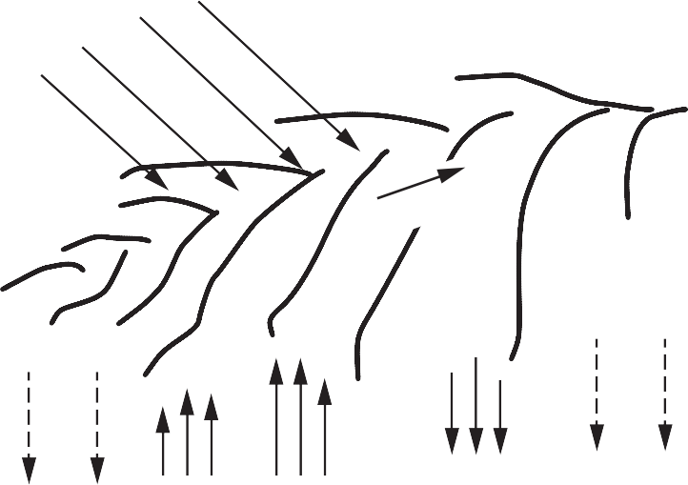Sunlight (energy)

Water (liquid)

Water (gas)
Water (gas)

Carbon dioxide Oxygen

General Equation for Photosynthesis
Reactants Products
light

carbon dioxide + water
energy
- List three things entering the leaf in Model 1.

- List three substances leaving the leaf.

- Which substance is both entering and leaving?
e
sugars + oxygen

- Veins are important structures that carry materials through the leaf. Label the central vein in the leaf diagram.

- How is the substance you identified in Question 3 changed between its entry and its exit?

- Use the general equation for photosynthesis and Model 1 to answer the following questions.
  - What are the reactants for photosynthesis?

  - Where do these reactants enter the leaf?

  - What are the products of photosynthesis?

  - From where do the products leave the leaf?

- Categorize all the components involved in photosynthesis as either matter or energy.

Model 2 – Cross Section of the Internal Structure of a Leaf

Upper epidermis Chloroplast
Cuticle

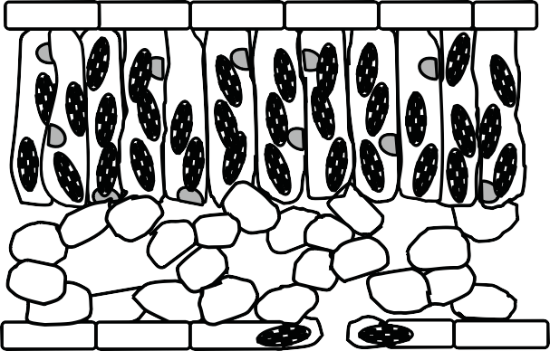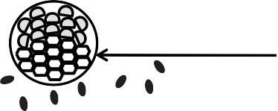Palisade mesophyll

Air Space Lower epidermis

Guard cell Stoma
Vein

Spongy mesophyll Cuticle

- List the layers of the leaf starting at the upper cuticle all the way to the lower cuticle.

Read This!

Inside plant veins are two different types of tissues. xylem carries water and minerals up from the roots of the plant and phloem carries the sugars (nutrients) away from the leaf to areas where the plant is growing or to storage areas in the plant.

- Describe the position of the vein(s) in each model.
  - In the leaf in Model 1.

  - Within the leaf cross section in Model 2.

- How does the placement of veins help to carry out their function of transporting materials to and from the leaf?

- Look back at your answers to Questions 1–3 and the photosynthesis equation. In the appropriate locations on Model 2, mark with labels and arrows what is entering the leaf and what is exiting the leaf.

- Which kind(s) of cells have chloroplasts in them?

- Remembering the function of chloroplasts, in which part(s) of the leaf is photosynthesis taking place?

- The green color of chloroplasts is due to a pigment in them that absorbs light energy. Knowing this, infer which layer inside a leaf gives the whole leaf its green color. Write one complete sen- tence to express your reasoning.

- Through which layer(s) does light energy travel to reach the palisade mesophyll?

- List at least three differences between the cells of the palisade mesophyll and the cells that make up the other areas within the leaf.

- How would the cylindrical shape of the palisade mesophyll cells increase the amount of photo- synthesis that the leaf can carry out?

- What would be the advantage(s) to having no chloroplasts in the cells of the spongy mesophyll?

- Suppose there were many chloroplasts in the cells of the upper epidermis. How would that change the amount of sunlight reaching the chloroplasts in the palisade layer?

- Considering its locations and your previous knowledge of the word, what do you think might be the function of the epidermis?

Read This!

The cuticle covering the upper and lower epidermis of land plants is made of a waxy substance that repels water in much the same way as wax on a paper cup.

- What is the purpose of having a water-tight covering?

- Look carefully at the lower surface of the leaf in Model 2.
  - What structure is found between guard cells?

  - How would you describe this structure?

  - How would this affect the ability of the leaf to retain water especially in dry conditions?

- Suggest a way in which the stoma and guard cells arrangement might work to control the amount of water that is leaving the leaf.

- What is the relationship between the stoma and an air space?

- Looking back at Model 1, what gases might you find inside the air spaces?

- During the time that stomata (the plural of stoma) are closed, gases cannot enter or leave. Explain how this would affect the plant’s ability to do photosynthesis.

- How would the cuticle and stomata work together to maintain the leaf ’s function?

- In grammatically correct sentences, trace the path of the reactants for photosynthesis as they enter the leaf.

- In grammatically correct sentences, trace the path of the products of photosynthesis as they exit the leaf.

Extension Questions
- Plants that live on the floor of forests tend to have much larger leaves than plants than live in hot, sunny conditions. Offer an explanation for this in which you refer to specific parts of the internal structure of a leaf.

- Cacti are plants that live in extremely dry environments. Unlike most other plants, cacti do not have regular leaves, but instead have spines. They do have green stems. How would the lack of regular leaves help cacti survive in their environment? In what part of the cacti would photosyn- thesis occur?

- Thinking about the structure and function of leaves, work with your group to propose modi- fications you might expect to see in the leaves of aquatic plants. Use the space below to make a sketch of the modified leaf, justifying what you include as well as what you leave out.

- Use your knowledge of plant cell structure to answer each of the following questions:
  - Where might water be stored for later use in the process of photosynthesis.

  - What might plant cells do with the sugars made during photosynthesis?

  - How does having cells with walls help a leaf to absorb as much energy as possible?

