Nuclear Chemistry
Definition Time
- Radioactivity
  - Physical property by which an atomic nucleus gives off _______________________________________________________
- Radiation
  - Penetrating rays emitted by a ______________________________
  - Energy emitted in different forms such as _________________________________________________________
- Radioisotopes
  - Isotopes that have an _______________________ & undergo radioactive decay
  - ___________________________________________!
- Radioactive decay
  - Process where an unstable nucleus loses energy by emitting _________________________________________________________
- Transuranium
  - Elements after at_____________
  - _________________________________________________________
- Transmutation
  - Where one atom of an element changes to an ___________________
- How can this occur?
  - Radioactive decay
  - Particles bombard the nucleus of the atom
- Nuclear Symbols

- Types of Radiation
____________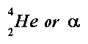 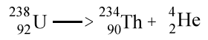
____________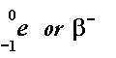 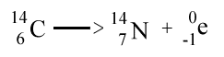
¹¹C → ¹¹N + ¹n
⁶ ⁷ ⁰
____________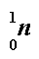
____________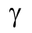 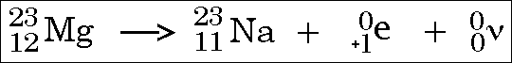

- Bombardment Power
- Practice Problems
  - 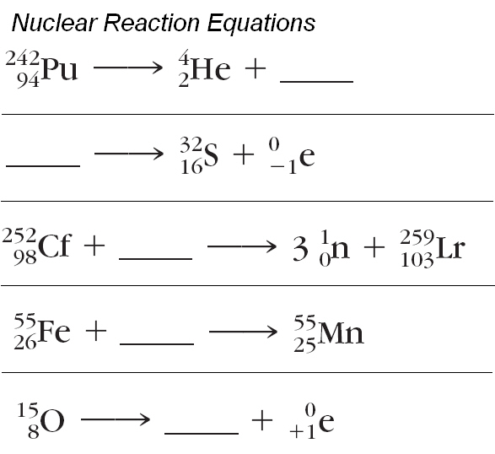
- What is fission?
- One nucleus splits into ______ smaller nuclei and typically a few neutrons by the bombardment of a neutron.
- U-235 is the only naturally occurring nuclide that fissions
- Watch this!
- One gram of U-235 can release enough energy during fission to raise the temperature of 66 million gallons of water from 25ºC to 100ºC!
- Nuclear power reactors are designed to use the controlled fission through chain reactions.
- What else can fission do?
- Fission is the culprit of the atomic bomb.
- Fission creates waste that has half-lives of several hundred years.
- What is fusion?
- A nuclear reaction in which two small nuclei combine (or fuse) to form __________________________________________________________________.
  - Takes place at ______________________________________!
  - Occurs on the ______________________ and also in the Hydrogen Bomb.
- Watch this!
- Fusion reactions
  - 1 lb. of fuel can release about _________________________________ more energy than 1 lb. of coal.
- Very little radioactive waste!
- Materials are cheap and readily available.
- The Hydrogen Bomb
- Also called a __________________________________bomb.
- Goal of the government is to make this a useful weapon by the year 2015.
- ______________________ is the only waste product.
- Uses fission bombs to reach the high temperatures to start a fusion reaction
- First Fusion Bomb Test (1952)
This test was conducted on an island. After the bomb went off, the __________________________________________________________________.
- So what about this cold fusion mumbo jumbo?
- The idea of cold fusion is to create the same power of fusion but at _______________________________________________________________.
- Almost impossible according to nuclear theory.
- 1989, Stanley Pons & Martin Fleischman ‘claimed’ this feat of science.
- Radiation Detectors
- Geiger Counter
- Developed by Hans Geiger and Ernest Rutherford in 1908.
  - Could only detect __________________ radiation
- Improved in 1928 to detect all kinds of ionizing radiation.
- Used in mining, nuclear physics and medical therapy with isotopes and x-rays.
- Film Badge
- Monitors exposure to ionizing radiation.
- If you are exposed to radiation, the film will develop…that’s how they discovered radioactivity in the first place?!?
- Different films are used to detect different forms of radiation.
- Not widely used in the USA
- Phosphor is used to detect radiation
- What is half-life?
- Half life - time it takes for one-half of the original sample to emit radiation and decay.
- All radioactive elements decay and all radioactive elements have a half-life.
  - Example: If I start with 20g of Uranium-238, which has a half-life of 5 years, how much is left after 15 years?

